B.K. Jewellers

**High Level Design (HLD)**

**Document for**

**“Manufacturing department” part.**

Document NO: 001

Date: 20-02-2020

Prepared by:

Group 2

* **Revision History**

|  |  |  |  |
| --- | --- | --- | --- |
| **Revision Number** | **Revision Date** | **Summary of changes** | **Author** |
| **1** | 20/02/2020 | Document made. | Vrajrajsinh jadeja |
| **2** | 18/04/2020 | * **Table of content:** Page numbers added. * **(1.3):** Software interface deleted from list. | Rudra soni |
| **3** |  |  |  |
|  |  |  |  |

* **Table of Contents** -

|  |  |  |
| --- | --- | --- |
| Sr no. | Content | Page no. |
| 1. | Introduction |  |
|  | * 1. Objective | 4 |
|  | 1.2 Scope | 4 |
|  | 1.3 Overview | 4 |
|  |  |  |
| 2. | General description |  |
|  | 2.1 Product perspective | 4 |
|  | 2.2 Tools used | 5 |
|  |  |  |
| 3. | General constrains | 5 |
|  |  |  |
| 4. | Assumptions |  |
|  | 4.1 Peripheral assumption | 5 |
|  | 4.2 Result assumption | 5 |
|  | 4.3 Knowledge assumption | 6 |
|  |  |  |
| 5. | Design details |  |
|  | 5.1 Application architecture | 6 |
|  | 5.2 Screen presentation | 6 |
|  | 5.3 Standards | 7 |
|  | 5.4 User interface | 7 |
|  | 5.5 Security | 7 |
|  | 5.6 Resource utilization | 7 |
|  | 5.7 Help | 8 |

1. **Introduction**
   1. Objective:

The purpose of this High Level Design (HLD) document is to add required details to the current project to make a suitable model for coding. This document can also be used as reference manual for how modules work at high level.

* 1. Scope:

The HLD document defines the full architecture of the “manufacturing” department in software.

* 1. Overview:

The HLD document will describe following:

* All the design aspects and defined in detail.
* User interface.
* Resource utilization.
* Design features & architecture of project.

1. **General description**
   1. Product perspective:

The working of “manufacturing” department is build with several components some of them are programmed and others are implemented from open-source programs.

This section will allow only one user to work with software on one machine.

There is only one user “manufacturing head” which can view

* Carat calculator,
* Work reports,
* Stock (raw material),
* Item reports,
* Transfer,
  1. Tools used:
* Unified modelling language (UML) design programs to generate all diagram.
* Backend data-base is NoSQL type based.

1. **General constrains**

The “manufacturing” department must be user friendly and 90% automatic.

Manufacturing head should not be required to know working of any other departments of an organization.

Entry is saved, manufacturing head can edit them.

1. **Assumptions**
   1. Peripheral assumption:

The “manufacturing” department can work on only Microsoft Windows (7/8.1/10/above) . The required specifications are at least 4 GB of RAM and 100 GB of free storage space.

* 1. Result assumption:

The goal is to make the working within organization will follow the strict rules and procedures with less efforts and make the process simpler as much as possible.

* 1. Knowledge assumption:

The final assumption is that the person is operating the software is aware of basic usage of computers and at least 80% awareness of rules and procedures of the organization as well as 95% of knowledge in their working expertises.

1. **Design details** 
   1. Application architecture:

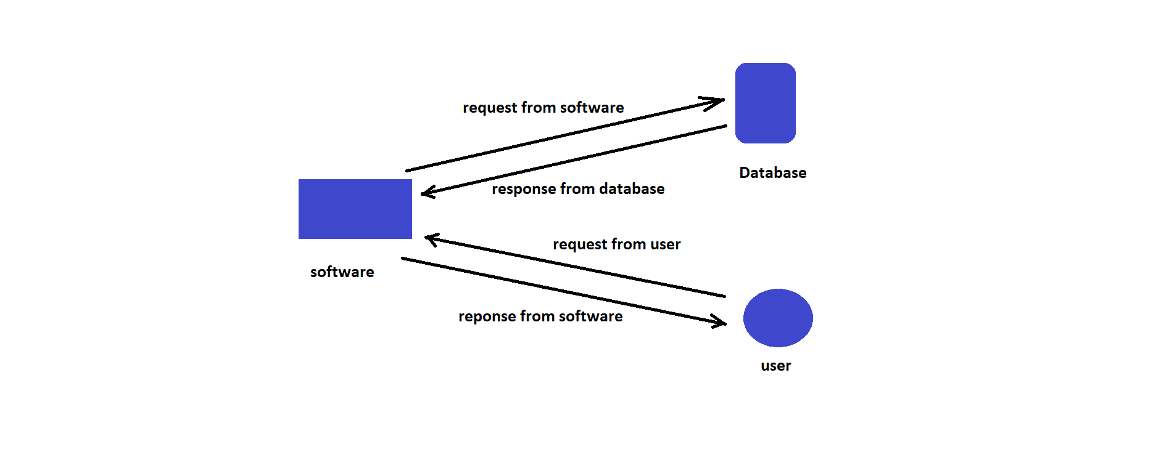

* 1. Screen presentation:

On “manufacturing head” side information will include

* Carat calculator,
* Work report,
* Stock,
* Item report,
* Transfer,
* Help.
  1. Standards:
* Inputs:- through barcode scanner and text fields.
* Security:- username and password are required.
* Quality:- by keeping simple and direct interface quality should be kept at a maximum.
* Accuracy:- the accuracy standard should always keep at very high when performing any operation.
  1. User interface:

The user interface is very simple plain layout with little to no graphics. It will display information very clearly for the users.

* 1. Security:

A username and password will be mandatory to log into the system as well as the software.

The generated voucher/report numbers shouldn’t be shown in any voucher/report afterwards.

* 1. Resource utilization:

When any task is performed, it will likely to use recommended processing power until that task get finished.

* 1. Help:

Help will come in the form of all documentation created prior to coding, which explain the intended user. Detailed instructions will be written in it.